Project Design Phase-II
Solution Requirements (Functional & Non-functional)

Date | 16 June 2026
Name | Mudit Manglik
Project Name | ShopEZ: E-Commerce Application

Functional Requirements:
Following are the functional requirements of the proposed solution.
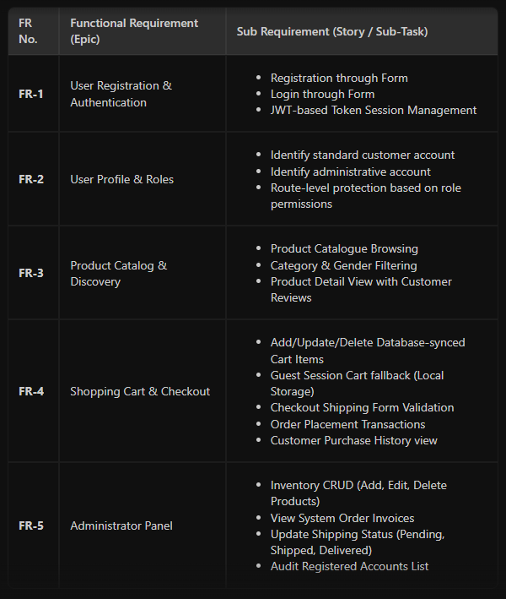

Non-functional Requirements:
Following are the non-functional requirements of the proposed solution.
